Nick Forleo

SWENG 581

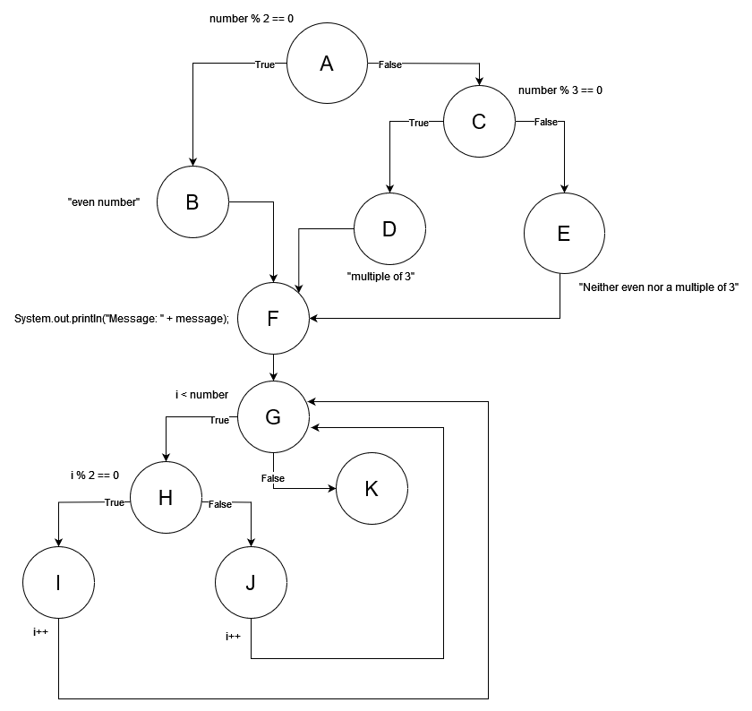

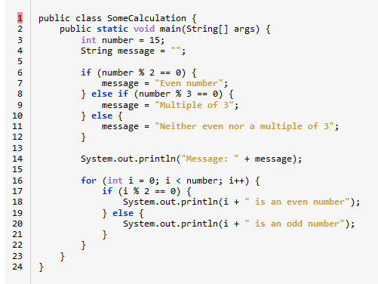

| A | 1, 2, 3, 4, 5, 6 |
| --- | --- |
| B | 7 |
| C | 8 |
| D | 9 |
| E | 10, 11, 12, 13 |
| F | 14, 15, 16: int i = 0; |
| G | 16: i < number; |
| H | 17 |
| I | 18, 16: i++ |
| J | 19, 20, 16: i++ |
| K | 22, 23, 24 |

All Node Coverage

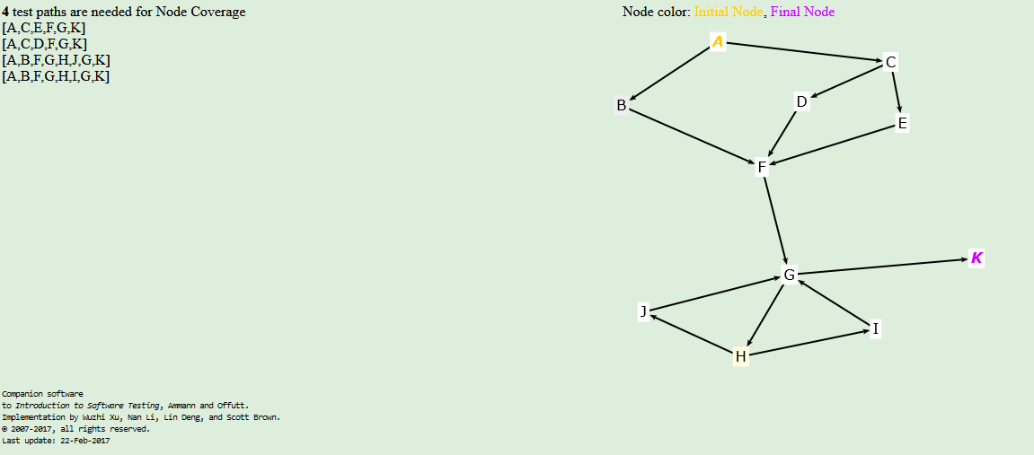

| **Path** | **Input** | **Output** |
| --- | --- | --- |
| [A,C,E,F,G,K] | -1 | Message: Neither even nor a multiple of 3 |
| [A,C,D,F,G,K] | -3 | Message: Multiple of 3 |
| [A,B,F,G,H,J,G,K] | Infeasible | There is no such number that is even and meets the condition to enter the for loop without executing Node I first |
| [A,B,F,G,H,I,G,K] | 2 | Message: Even number  0 is an even number  *1 is an odd number*  (This assume we can hit extra nodes, but if we can’t then this is infeasible because any even number that pass for loop condition will hit both Node I and Node J) |

All Edge Coverage

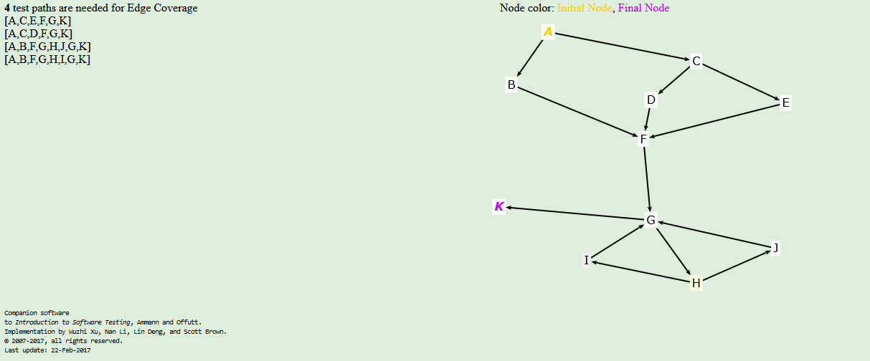

| **Path** | **Input** | **Output** |
| --- | --- | --- |
| [A,C,E,F,G,K] | -1 | Message: Neither even nor a multiple of 3 |
| [A,C,D,F,G,K] | -3 | Message: Multiple of 3 |
| [A,B,F,G,H,J,G,K] | Infeasible | There is no such number that is even and meets the condition to enter the for loop without executing Node I first |
| [A,B,F,G,H,I,G,K] | 2 | Message: Even number  0 is an even number  *1 is an odd number*  (This assume we can hit extra nodes, but if we can’t then this is infeasible because any even number that pass for loop condition will hit both Node I and Node J) |

Simple Path Coverage

Below image shows all of the simple paths

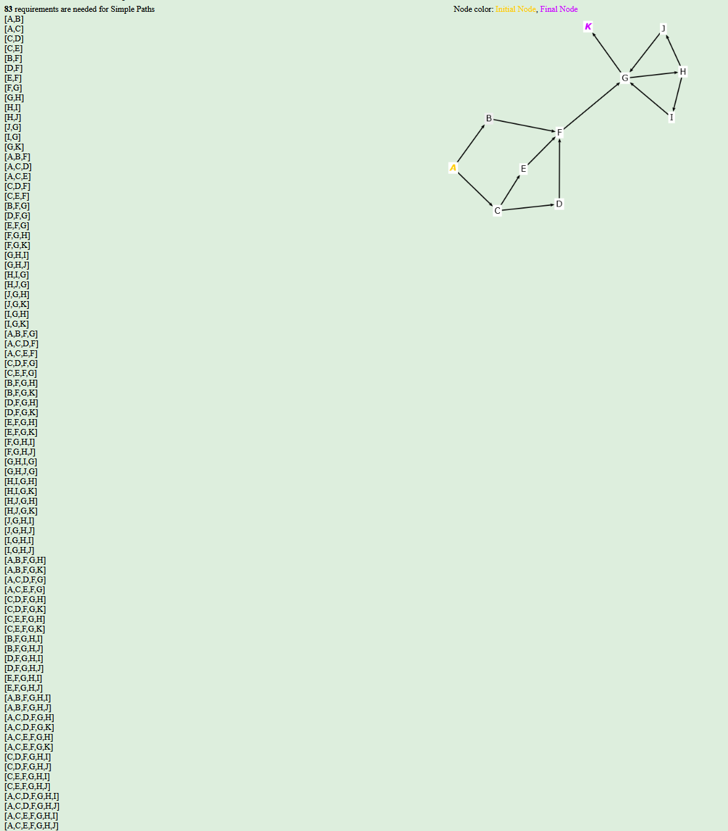

However, there is no input that will start in the middle of the graph, so I will use the generated Prime Paths, since a prime path is made up of simple paths (as defined by the textbook). This way a valid input can be provided and the path will terminate correctly.

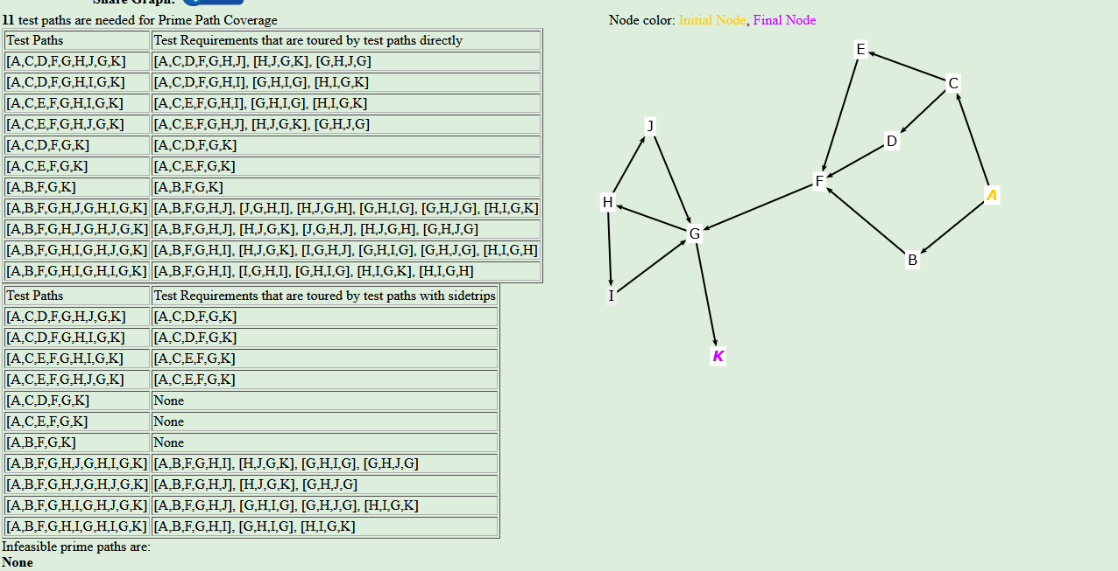

| **Path** | **Input** | **Output** |
| --- | --- | --- |
| [A,C,D,F,G,H,J,G,K] | Infeasible | There is no such number that is a multiple of 3 that will also meet the condition of Node H without first visiting Node I |
| [A,C,D,F,G,H,I,G,K] | Infeasible | This is no such number that is a multiple of 3 that will meet the condition of Node H to visit Node I then terminate after visiting Node G. For example if the input is 3, the path would be [A,C,D,F,G,H,I,G,**H,J,G,H,I**,K] |
| [A,C,E,F,G,H,I,G,K] | 1 | Message: Neither even nor a multiple of 3  0 is an even number |
| [A,C,E,F,G,H,J,G,K] | Infeasible | There is no such number that is neither even nor a multiple of 3 that will meet the condition of Node G but fail the condition of Node H |
| [A,C,D,F,G,K] | -3 | Message: Multiple of 3 |
| [A,C,E,F,G,K] | -1 | Message: Neither even nor a multiple of 3 |
| [A,B,F,G,K] | 0 | Message: Even number |
| [A,B,F,G,H,J,G,H,I,G,K] | Infeasible | There is no such number that is even and meets the condition of Node G that will fail the condition of Node H |
| [A,B,F,G,H,J,G,H,J,G,K] | Infeasible | There is no such number that is even and meets the condition of Node G that will fail the condition of Node H |
| [A,B,F,G,H,I,G,H,J,G,K] | 2 | Message: Even number  0 is an even number  1 is an odd number |
| [A,B,F,G,H,I,G,H,I,G,K] | Infeasible | There is no such number that will meet the condition of Node G and then meet the condition of Node H twice in a row. |